Order Of Service

Singing: Psalm 100—CW page 104

Reading: Psalm 89:29-37

Opening Hymn: CW 496

Reading: Acts 16:11-15

Request Hymn: CW Supplement 749

Reading: Matthew 5:27-30

Sermon Hymn: CW 363

Sermon Text: Mark 3:7-12

Withdrawing To The Sea

Prayer

The Apostles’ Creed, TLH page 12

Holy Communion

The Lord's Prayer

The Blessing

Closing Hymn: CW 449

* * * * * * * * * * *

Koinonia Hour


Winter In North Carolina

Water
Of
Life

6 January 2019

W A T E R O F L I F E

Independent Christian Church—Conservative Lutheran Doctrine

Worship Service: 9:30 a.m. Bible Study: 10:45 a.m.

Larry Cooper, Pastor E-Mail address:
111 N. Ridge Road lcooper@wateroflife.cc
Coon Valley, WI 54623 Web Site:
www.wateroflife.cc

* * * * * * * * * * * * * * * * * * * * * * * * * * *

Sermon Text: Mark 3:7-12

Withdrawing To The Sea

* * * * * * * * * * * * * * * * * * * * * * * * * * *

Mark 3:7 But Jesus withdrew himself with his disciples to the sea: and a great multitude from Galilee followed him, and from Judaea,
:8 And from Jerusalem, and from Idumaea, and from beyond Jordan; and they about Tyre and Sidon, a great multitude, when they had heard what great things he did, came unto him.
:9 And he spake to his disciples, that a small ship should wait on him because of the multitude, lest they should throng him.
:10 For he had healed many; insomuch that they pressed upon him for to touch him, as many as had plagues.
:11 And unclean spirits, when they saw him, fell down before him, and cried, saying, Thou art the Son of God.
:12 And he straitly charged them that they should not make him known.

* * * * * * * * * *

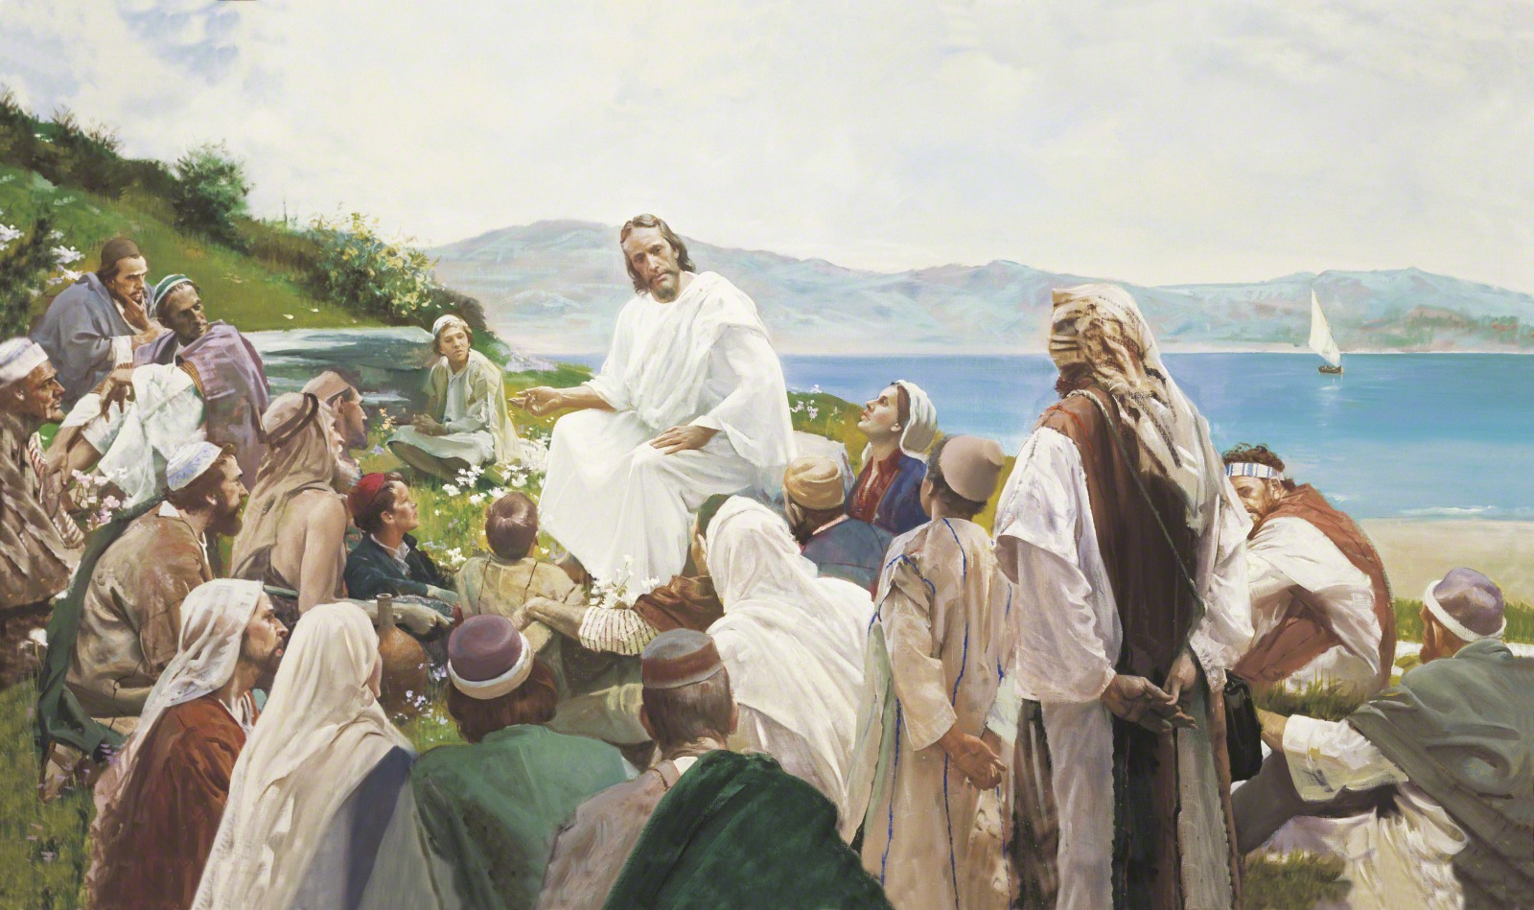

There were times in the ministry of Jesus when great multitudes came to him. They flocked to him “when they had heard what great things he did.” “For he had healed many.”

It didn’t last. At the end of the three years of his public ministry, there were only a handful of followers left. There is a good reason why.

See Matthew 13:1-9.

